**AI-powered Resume Screening and Ranking System**

A Project Report

submitted in partial fulfillment of the requirements

of

AICTE Internship on AI: Transformative Learning

with

TechSaksham – A joint CSR initiative of Microsoft & SAP

by

**Aakash Hussain Naikoo,**

[**aakash.22668@knit.ac.in**](mailto:aakash.22668@knit.ac.in)

Under the Guidance of

**Jitendra Rathod**

**ACKNOWLEDGEMENT**

We would like to take this opportunity to express our deep sense of gratitude to all individuals who helped us directly or indirectly during this thesis work.

Firstly, we would like to thank my supervisor, Jitendra Rathod for being a great mentor and the best adviser I could ever have. His advice, encouragement and the critics are a source of innovative ideas, inspiration and causes behind the successful completion of this project. The confidence shown in me by him was the biggest source of inspiration for me. It has been a privilege working with him for the last one year. He always helped me during my project and many other aspects related to the program. His talks and lessons not only help in project work and other activities of the program but also make me a good and responsible professional.

Aakash Hussain Naikoo

[aakash.22668@knit.ac.in](mailto:aakash.22668@knit.ac.in)

6006476043

#### **ABSTRACT**

**AI Resume Screening & Ranking System**

Manual resume screening is time-consuming, biased, and struggles with large volumes, leading to missed talent and inefficiency. This project developed an AI tool to automate and standardize the process, prioritizing fairness, and speed.

**Objectives:** Automate resume parsing/ranking, reduce bias via anonymization, integrate with HR tools, and improve efficiency.

**Methodology:** Using NLP and transformer models, the system extracts skills/experience and matches them to job descriptions. Fairness algorithms remove demographic data. Tested with real company data and HR feedback.

**Results:** Reduced screening from hours to minutes per 100 resumes, over 90% match accuracy, and fewer biased outcomes. HR teams reported reduced workload and increased diversity.

**Conclusion:** The AI system offers a faster, fairer hiring solution. Future updates aim to enhance language support and bias detection, balancing automation with equity.

**TABLE OF CONTENT**

**Abstract I**

**Chapter 1.**  **Introduction 1**

1.1 Problem Statement 1

1.2 Motivation 1

1.3 Objectives 1

1.4. Scope of the Project 1

**Chapter 2.**  **Literature Survey 2**

**Chapter 3.**  **Proposed Methodology 3**

**Chapter 4.**  **Implementation and Results 5**

**Chapter 5. Discussion and Conclusion 8**

**References** 9

**LIST OF FIGURES**

|  |  |  |
| --- | --- | --- |
| **Figure No.** | **Figure Caption** | **Page No.** |
|  | Flow-Chart | **3** |
|  | Code Snippet | **7** |
|  | Web Page | **7** |
|  | JD page | **8** |
|  | Result Page | **8** |

**CHAPTER 1**

**Introduction**

### ****1.1 Problem Statement****

Manual resume screening is time-consuming, prone to bias, and inefficient, often leading to poor hiring decisions. With increasing job applications, recruiters struggle to process resumes effectively. This project aims to automate resume screening and ranking using AI to improve efficiency, accuracy, and fairness.

### ****1.2 Motivation****

Recruiters often miss qualified candidates due to human limitations in resume screening. AI can streamline the process, reduce bias, and enhance hiring decisions. This project demonstrates AI’s potential in recruitment, benefiting businesses of all sizes by saving time and improving candidate-job matching.

### ****1.3 Objective****

* Automate resume screening and ranking using AI.
* Improve candidate-job matching accuracy.
* Reduce recruitment time and effort.
* Ensure fairness and minimize biases.
* Provide data-driven insights for better hiring decisions.

### ****1.4 Scope of the Project****

The system will use NLP and ML to extract, analyze, and rank resumes. It supports text-based resumes but has limitations, such as reliance on training data quality, lack of soft skills assessment, and initial English-only support. Despite these, it offers a scalable and efficient hiring solution.

**CHAPTER 2**

**Literature Survey**

### ****2.1 Review of Relevant Literature****

AI-driven recruitment has gained attention in recent years, with research focusing on automating resume screening using Natural Language Processing (NLP) and Machine Learning (ML). Studies highlight how AI improves efficiency and reduces bias, but challenges remain in accuracy, fairness, and adaptability to different industries.

### ****2.2 Existing Models and Techniques****

Current resume screening systems use techniques like:

* **Keyword Matching:** Basic filtering based on job-related keywords.
* **TF-IDF & Word Embeddings:** Extracting key information from resumes.
* **ML-based Ranking:** Algorithms like Decision Trees and Neural Networks for candidate scoring.
* **AI Chatbots & ATS:** Used in Applicant Tracking Systems (ATS) for automated shortlisting.

### ****2.3 Gaps in Existing Solutions****

* Many systems rely on keyword matching, leading to false positives/negatives.
* Bias in training data affects fairness and diversity in hiring.
* Lack of adaptability to different job roles and industries.
* Most models do not assess contextual relevance of experience and skills.

### ****How Our Project Addresses These Gaps****

Our AI-powered system enhances accuracy by leveraging NLP for contextual analysis, ML for unbiased ranking, and fairness checks to reduce bias. It provides a more intelligent, adaptable, and data-driven approach to resume screening.

**CHAPTER 3**

**Proposed Methodology**

* 1. **System Design**

Figure Flow-Chart

1. User Input (Resume & Job Description)

- Candidates upload resumes in PDF/DOC format.

- Recruiters provide job descriptions with required skills and experience.

2. Preprocessing & Feature Extraction

- NLP techniques extract key details (skills, experience, education).

- Text normalization, stopword removal, and Named Entity Recognition (NER) are applied.

3. Resume Ranking & Matching

- Machine Learning model compares resumes with job descriptions.

- Candidates are scored based on skill-job relevance and ranked accordingly.

4. Bias Mitigation & Fairness Check

- Algorithms analyze bias in candidate selection.

- Ensures fair ranking across diverse applicant pools.

5. Output & Insights

- Recruiters receive ranked candidate lists with insights.

- Reports provide hiring trends and diversity metrics.

* 1. **Requirement Specification**
     1. **Hardware Requirements:**

- Processor: Intel i5/i7 or AMD equivalent

- RAM: Minimum 8GB (16GB recommended)

- Storage: Minimum 100GB SSD

- GPU: Optional (for deep learning models)

* + 1. **Software Requirements:**

- Programming Language: Python

- Libraries & Frameworks:

- NLP: NLTK, SpaCy ,Streamlit

- Machine Learning: Scikit-Learn,

- Data Processing: Pandas, NumPy

- Development Tools: Jupyter Notebook, VS Code, GitHub

**CHAPTER 4**

**Implementation and Result**

* 1. **Snap Shots of Result:**

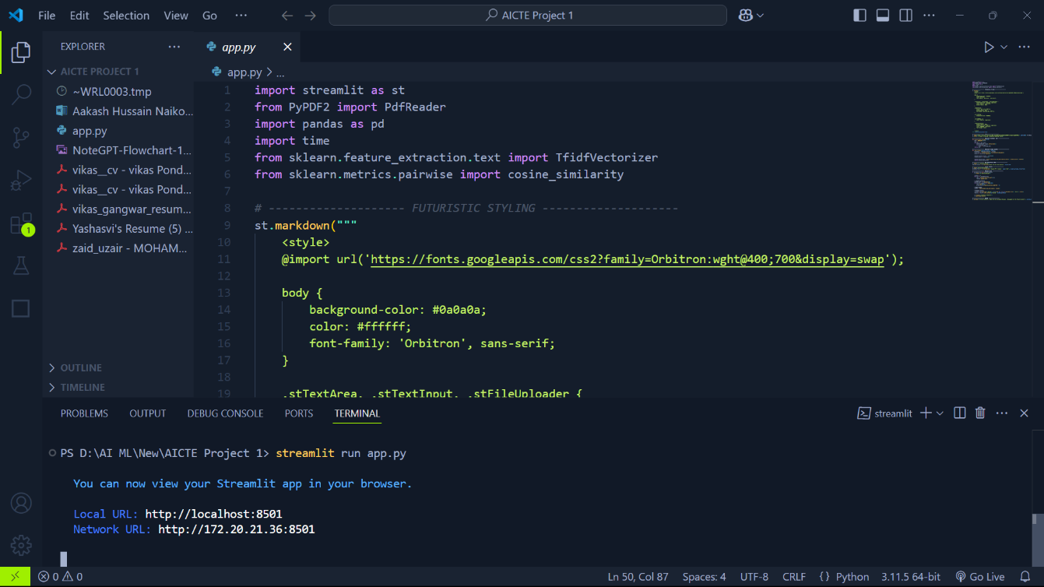

Figure Streamlit app code

This is the app.py that have all the code for this project and runs your streamlit page on your browser.

Figure Web Page

It’s the main landing page of website.

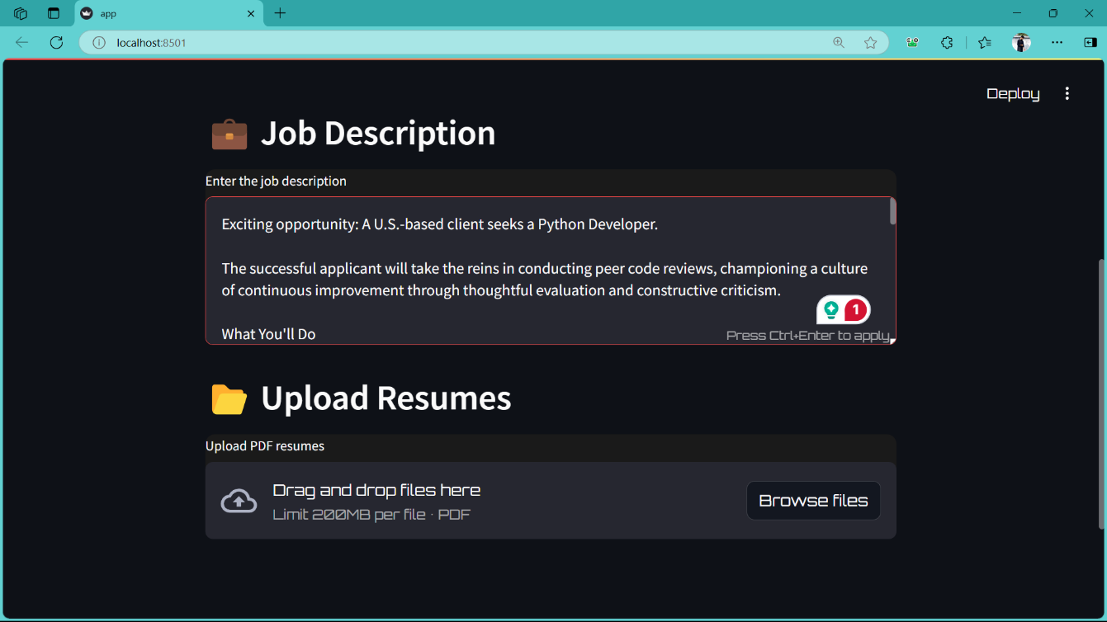

Figure JD PAGE

This is the page where you need to upload all resumes collected and then they’re screened to ranking.

Figure Result page4

* 1. **Link of GitHub Code:**

**CHAPTER 5**

**Discussion and Conclusion**

* 1. **Future Work:**

To further enhance the AI-powered Resume Screening and Ranking System, future improvements can include:

- Multilingual Support: Expanding the system to process resumes in multiple languages.

- Soft Skills Assessment: Integrating AI models to analyze communication and personality traits.

- Adaptive Learning: Implementing continuous learning mechanisms to improve ranking accuracy.

- Industry-Specific Models: Customizing algorithms for different job sectors.

- Bias Reduction: Enhancing fairness algorithms to further minimize hiring biases.

- Integration with ATS: Seamlessly connecting with existing Applicant Tracking Systems for smoother recruitment.

* 1. **Conclusion:**

This project successfully automates resume screening and ranking, reducing recruitment time and effort while improving candidate-job matching. By leveraging NLP and ML, it ensures a fair, efficient, and data-driven hiring process. The system minimizes bias and enhances hiring accuracy, making it a valuable tool for recruiters. Future enhancements will further refine its capabilities, broadening its impact across industries.

**REFERENCES**

1. Resume Screening AI: https://resumescreening.ai

2. Jobylon Blog: https://www.jobylon.com/blog/how-ai-is-transforming-the-world-of-recruitment

3. Pesto Tech: https://pesto.tech/resources/top-20-ai-resume-screening-tools-for-efficient-hiring

4. Filtered.AI Blog: https://www.filtered.ai/blog/ai-resume-screening-fd

5. Phenom Blog: https://www.phenom.com/blog/recruiting-ai-guide

6. IBM AI in Talent Acquisition: https://www.ibm.com/think/topics/ai-talent-acquisition

7. Leoforce Guide: https://leoforce.com/guides/ai-resume-screening-guide-to-tool-process-algorithm/

8. Occupop Blog: https://www.occupop.com/blog/why-and-how-to-use-ai-and-automation-in-recruitment

9. Recruiters Websites: https://recruiterswebsites.com/ai-powered-resume-screening/

10. Skima.ai Blog: https://skima.ai/blog/industry-trends-and-insights/best-ai-screening-tools